**  
“ZEBRA QR CODE BASED ATTENDANCE SYSTEM”**

Submitted by: -

|  |  |  |
| --- | --- | --- |
| **S.No.** |  | **Name** |
| 1. |  | Nikhil Nair |
| 2. |  | G Nitish Kumar Pillai |
| 3. |  | Darshan Pandharkar |

Date: 05/10/2021

**CONTENTS**

|  |  |
| --- | --- |
| **S.NO.** | **TOPIC** |
| 1. | INTRODUCTION |
| 2. | ER DIAGRAM |
| 3. | USE-CASE DIAGRAM |
| 4. | CLASS DIAGRAM |
| 5. | ACTIVITY DIAGRAM |
| 6. | SEQUENCE DIAGRAM |
| 7. | STATE DIAGRAM |
| 8. | PROJECT SCREENSHOTS |
| 9. | TESTING |
| 10. | CONCLUSION |

**INTRODUCTION**

* 1. Problem Statement

Manual Attendance system as we all know is a really time consuming and inefficient process. In the manual Attendance taking process Faculty have to call out student’s names in order to mark their attendance which is rather tiring process and if that’s not the case the faculty passes their respective attendance sheet for students to mark it which the chances of proxy.

Even after the sudden shift from offline to online the struggle has only increased over the period of time as they have to face a lot of impediments like network issues, mic issues, proxy issues just to name a few. In the case of manual attendance system there are issues related to data handling and document management which can be solved by making the whole system digital thereby reducing load on the teaching faculty who would not have the need for maintaining the records on their own.

In Certain organization, faculty are well aware of their responsibility of attendance tracking however they do not have the support tools to perform the specific tasks.

* 1. About the Project

In order to solve the above-mentioned problem, we have come to the conclusion that QR code-based attendance system would be an appropriate solution to tackle this. So, our project consists of a website and a mobile app. The website is basically created for the Teachers/Faculty who can register and login to the website and can easily generate the QR code for any particular lecture and the other part of the project will be the mobile application in which a student can register or login by giving their details like class, name, roll number and on the basis of that they can mark their respective attendance by scanning the QR code which was generated by the teacher/faculty and we have also added the functionality where the application checks whether the QR code being scanned is the same QR code provided by the teaching faculty and thereby notifies the student whether or not their attendance has been marked or not.

1.3 Technologies Used

**TOOLS AND TECHNOLOGY USED FOR APP-DEVELOPMENT**

* Android Studio
* XML
* Kotlin
* Zxing library (scanner)
* Glide Library room
* Firebase
* Firestore (database)

**TOOLS AND TECHNOLOGY USED FOR WEB-DEVELOPMENT**

* HTML
* CSS
* PHP
* Javascript
* Bootstrap
* Atom (text editor)
* Qrious (library)
* MYSQLi (database)

1.4 Plan of Work.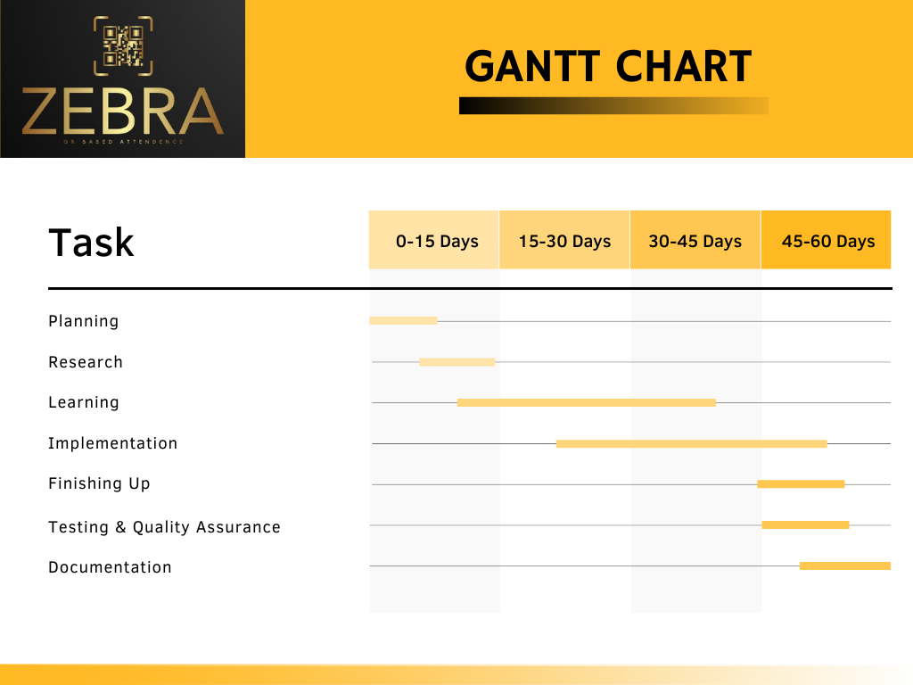

* 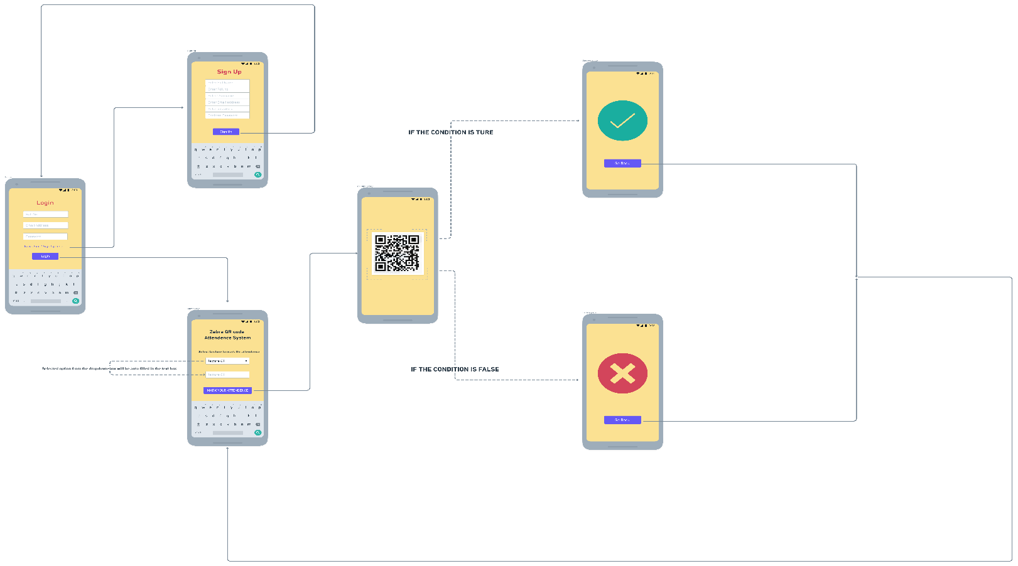**APP Wireframe**
* 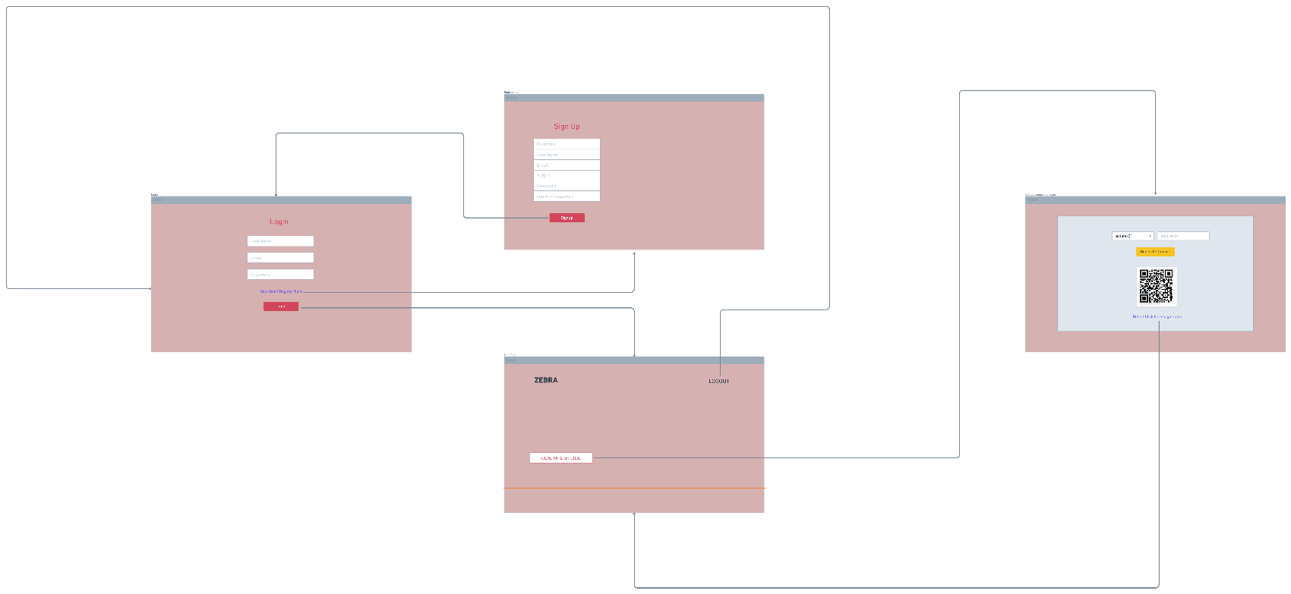**Website Wireframe**

**2. ER DIAGRAM**

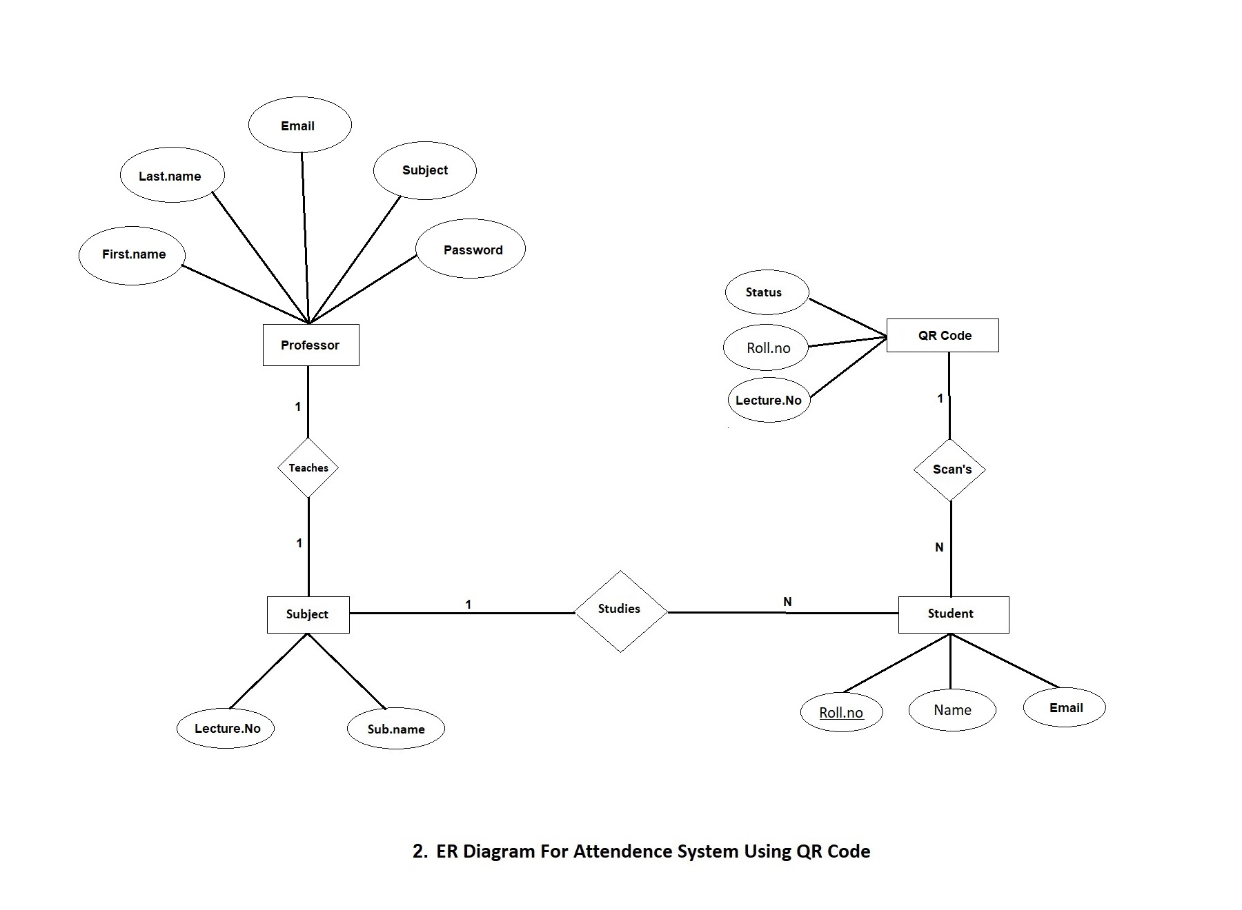

**3. USE-CASE DIAGRAM**

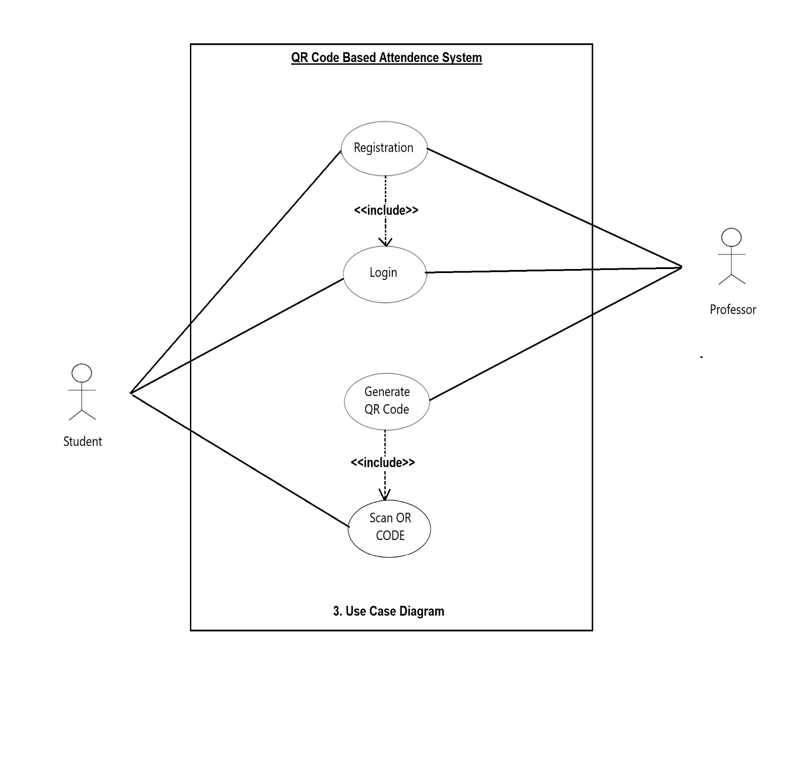

**4. CLASS DIAGRAM**

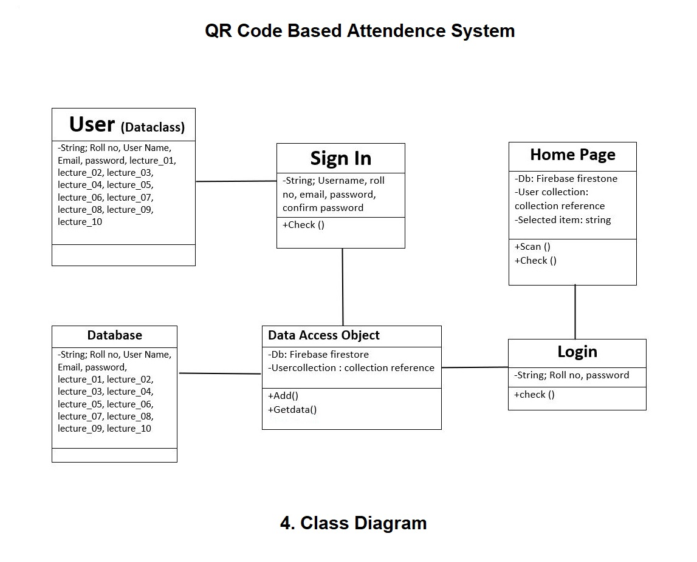

**5. ACTIVITY DIAGRAM**

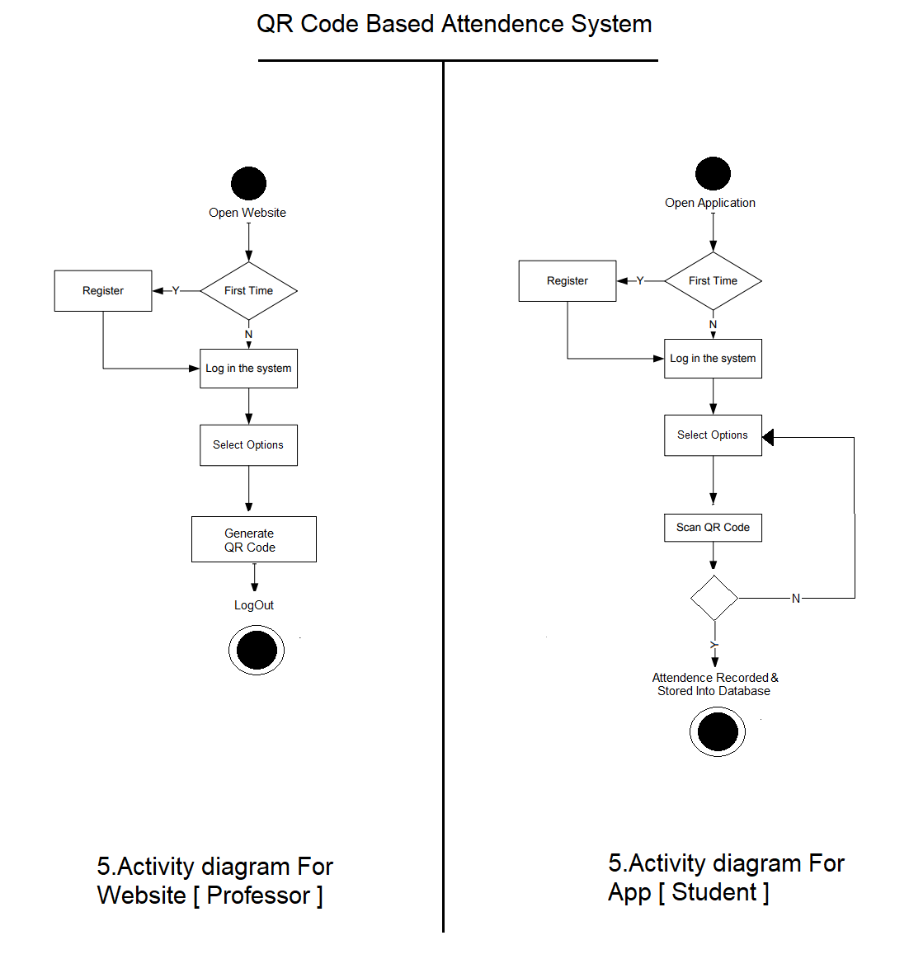

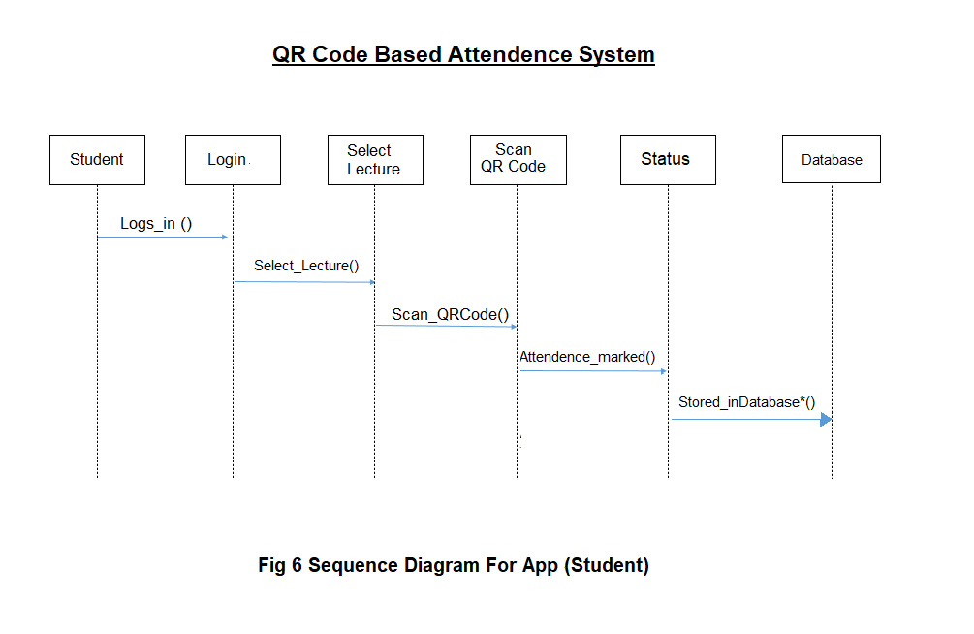**6. SEQUENCE DIAGRAM**  
  
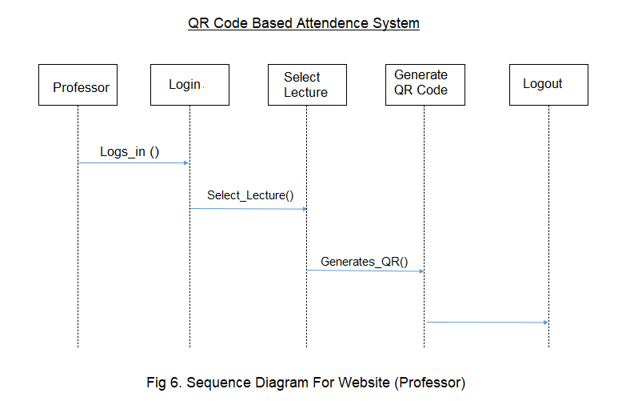  
**7. STATE DIAGRAM**  
  
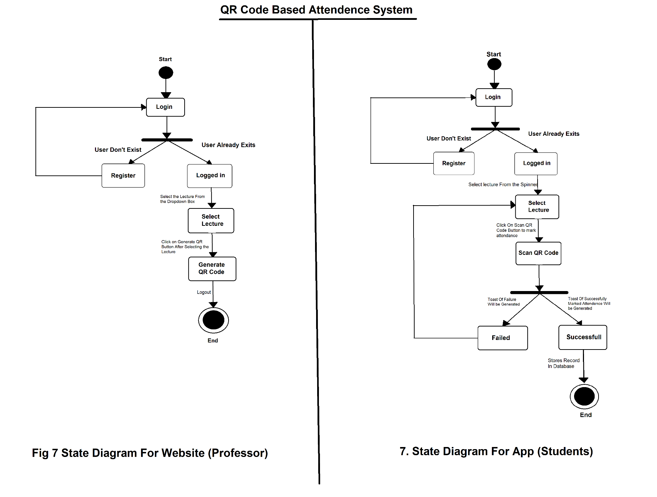

**8. PROJECT SCREENSHOTS**

**Website Screenshots: -**

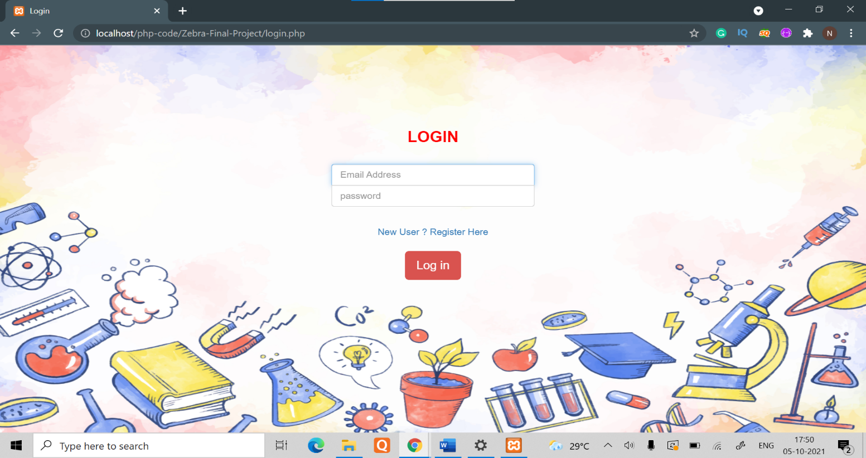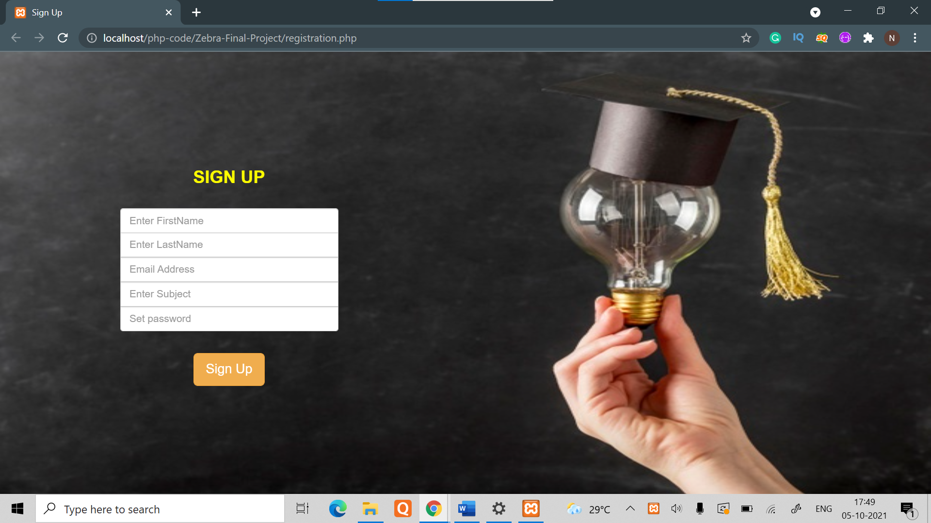*Login & Signup page*

*Main Page :-*

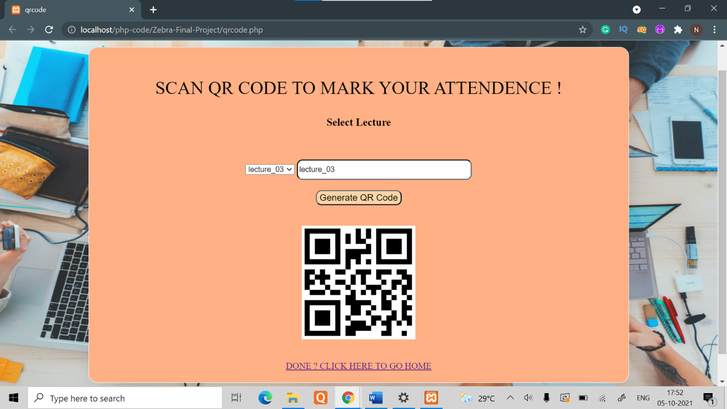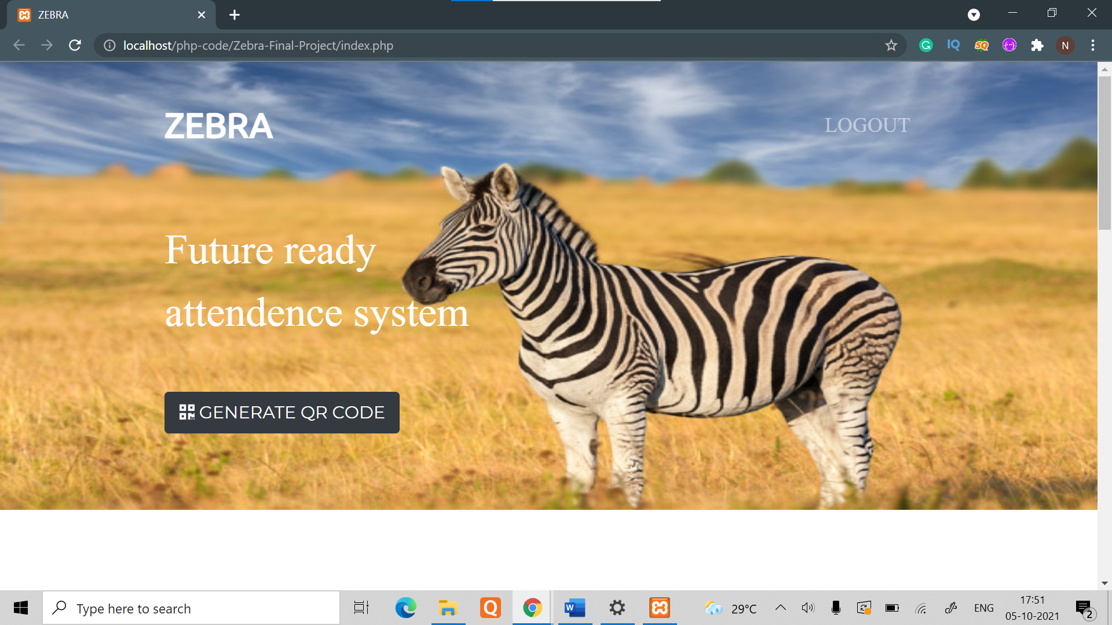  
  
*QR Code Page:-*

*Database Page: -*

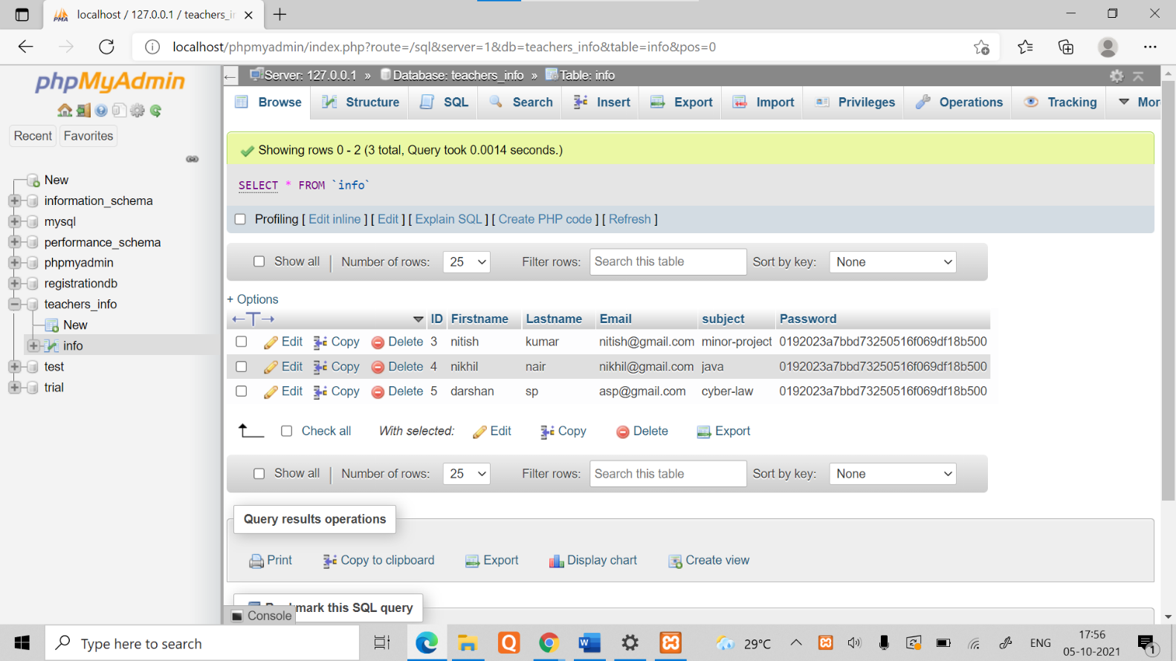

**App Screenshot: -**

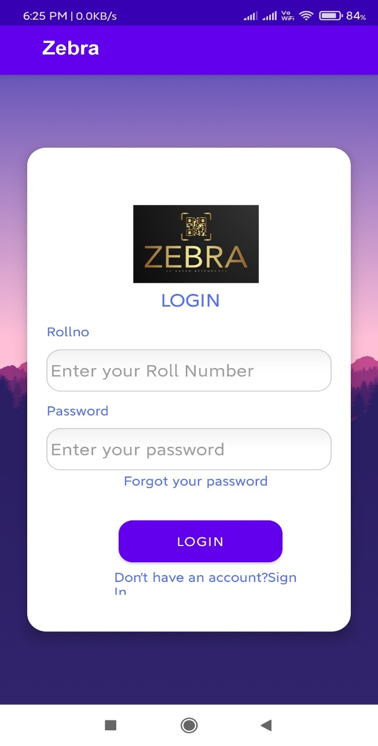

*Login Page:-*

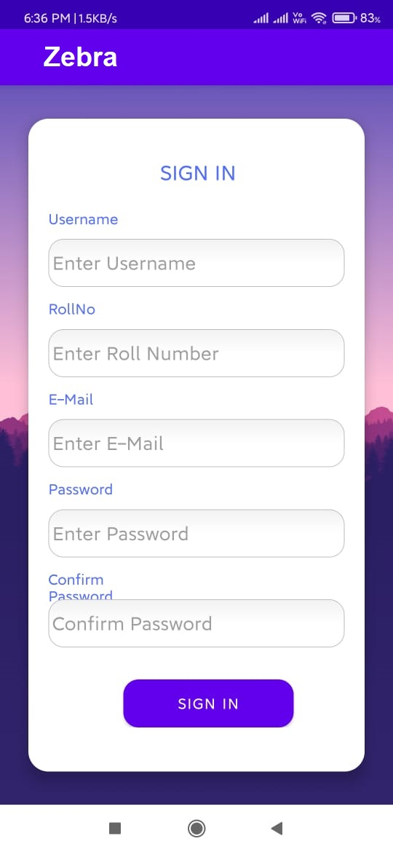

*Signup Page*

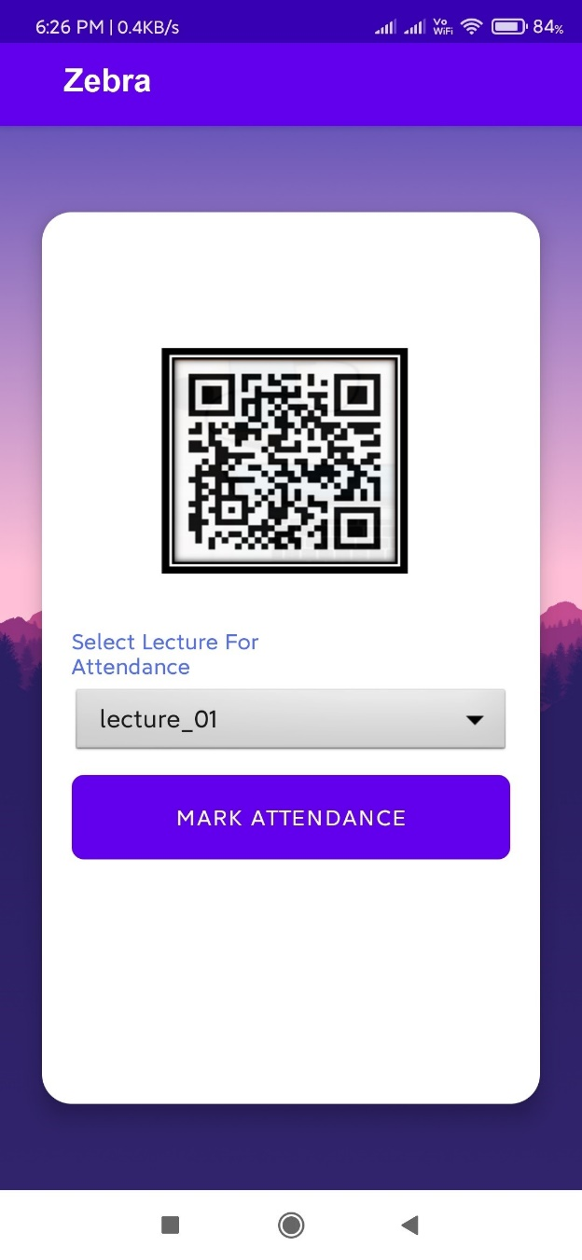

*Home Page*

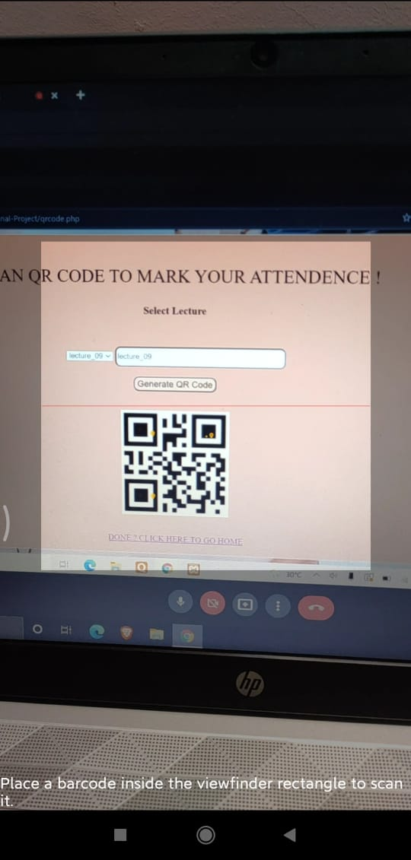

*Scanner Page:-*

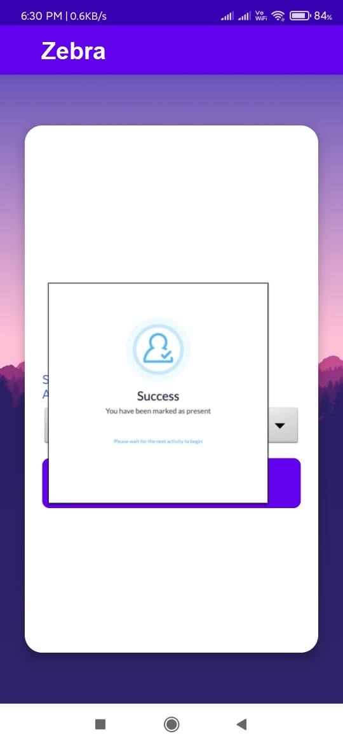

*Attendance Marked  
 Successful Pop-up*

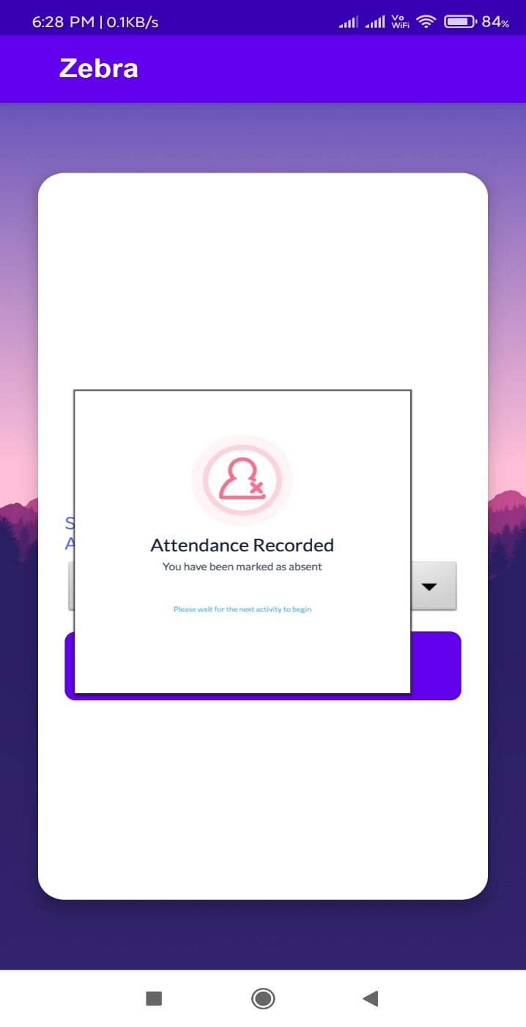

*Attendance Marked   
Failed Pop-up*

*App database :-*

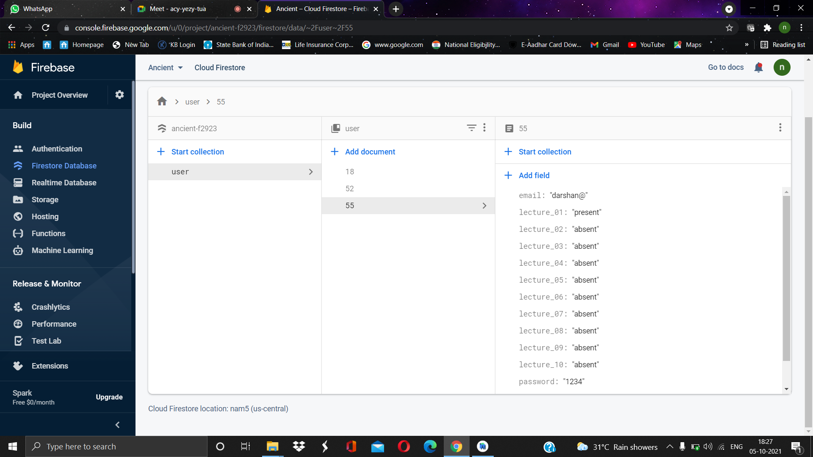

9. TESTING

|  |  |  |  |
| --- | --- | --- | --- |
| Test Case 1  Test Case Name: Login, Register, QR Code Generation and Log Out  Application: **Website Testing.** | | | |
| Step | Procedures | Expected Result | Result |
| 1 | Register using name, email and password | Save the insert data into database | Success |
| 2 | Insert correct Email,  password for login | Verify the user credentials. | Success |
| 3 | Click ‘Register,' ‘Login’ button | Application redirect user to Login page after register and Main page after login | Success |
| 4 | Repeat step 2 and 3 for login using false username, password | Application display error message | Success |
| 5 | Click on generate QR Code button | Redirect to QR generation Page | Success |
| 6 | Select the lecture option from the drop down & click on Generate QR Code button | QR Code of that selected lecture to be Generated | Success |
| 7 | Log Out Account | Log out redirected to Login page | Success |
| Precondition | | No credentials are currently login | |
| Post-condition | | New User Name, Subject, password and email saved in Database. | |

|  |  |  |  |
| --- | --- | --- | --- |
| Test Case 2  Test Case Name: Login, Register, QR Code Scanner and Log Out  Application: **APP Testing.** | | | |
| Step | Procedures | Expected Result | Result |
| 1 | Register using name, Roll No, email and password | Save the insert data into database | Success |
| 2 | Insert correct Roll no  password for login | Verify the user ID | Success |
| 3 | Click ‘Register,' ‘Login’ button | Application redirect user to Login page after register and Main page after login | Success |
| 4 | Repeat step 2 and 3 for login using false Roll No, password | Application display error message | Success |
| 5 | Select the lecture option from the spinner & click on Scan QR Code button | QR Code of that selected lecture to be Scanned | Success |
| 6 | Click on Scan QR Code button | Open QR Code Scanner | Success |
| 7 | Repeat Step 5th & 6th for incorrect lecture selection. | Application Display Result  Pop up | Success |
| 8 | Log Out Account | Log out redirected to Login page | Success |
| Precondition | | No credentials are currently login, default lecture data is absent. | |
| Post-condition | | New Roll no, password, email and for student saved in Database. If the given QR Code is Scanned correctly default lecture data is updated to present. | |

10. CONCLUSION

This project started with an aim to solve the time-consuming attendance taking process by replacing the stereotypical way of taking the attendance with a QR code-based attendance system in which a teacher can use the website and can generate a QR code using a button-click given on the website and after the with help of a mobile app which was developed by us can be used to scan the QR code to mark the attendance for the specific lecture. The app has to check functionality which checks whether the scanned QR code is the same as that of generated QR code if this condition satisfies then only it allows the entry of that user into the database which makes it much safer which means the chances of proxy reduces also it is almost 10 times faster than the normal way of taking the attendance which makes it more efficient. hence, QR code-based attendance system has met its objective by providing a website and an application that can generate and scan a QR code and also recording the specific data in the database.